Vienna: Main places to cover:
- St. Stephen’s cathedral
- Hofburg Palace (Sisi Museum) - 9 AM - 5.30 PM, last entry 4.30 PM
- Belvedere Palace (Upper Belvedere Kiss, 9 AM - 6 PM, last entry 5.30 pm)
- Schonbrunn Palace (Need to buy timed entry ticket)
- Prater (Vienna Giant Ferris Wheel) – 1 km from our place. Should be a 6 pm activity
- Cruise on Donaukanal (75 minutes)
https://ddsg-blue-danube.at/cruises-vienna/city-cruise/?lang=en
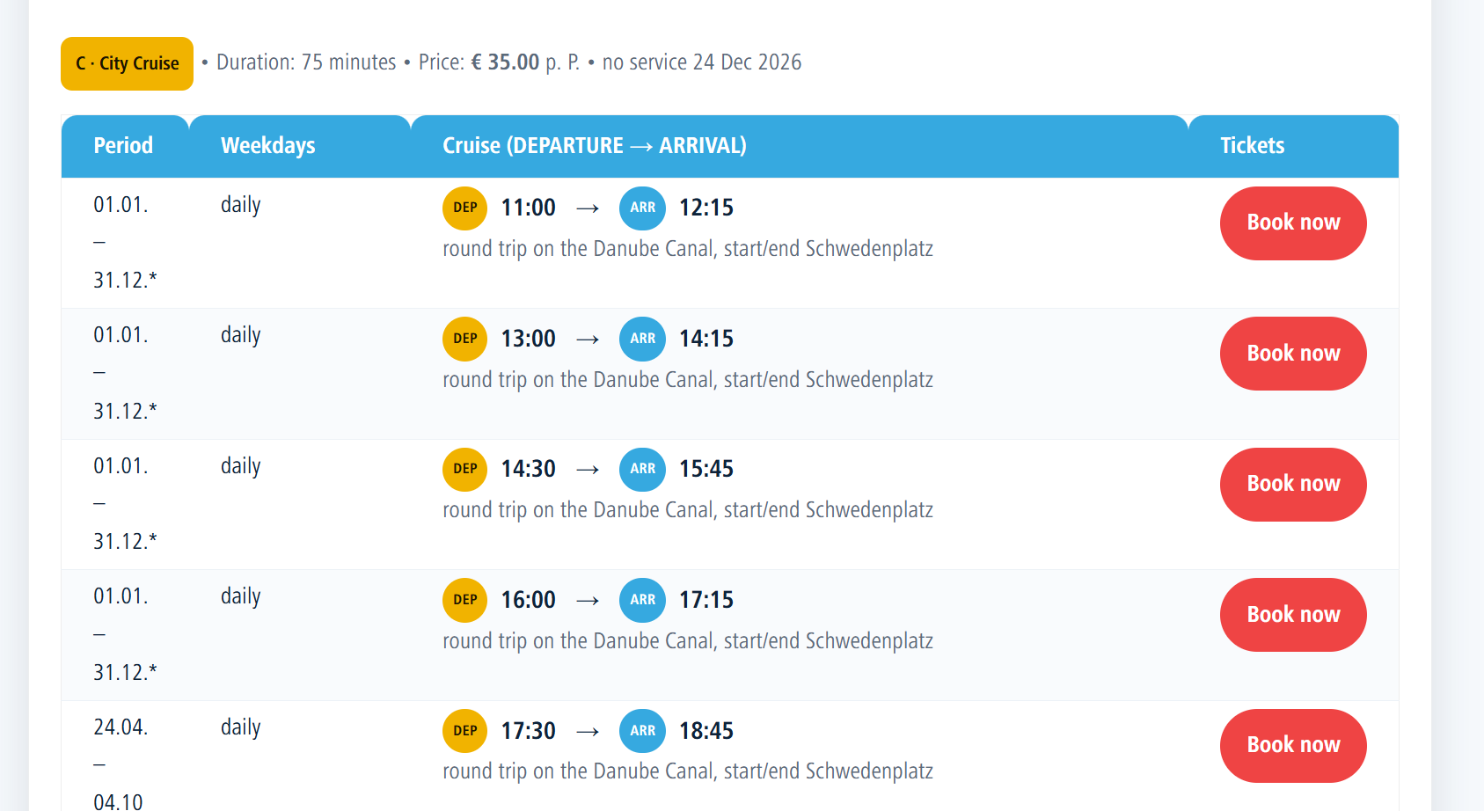

St. Stephen’s cathedral: Main cathedral is free 6 AM - 10 PM, others need ticket, South tower is higher and provides better view. North tower has elevator access

Itinerary in Vienna:
August 8: St. Stephen’s Cathedral, Hofburg Palace [UR] Can we walk around the historic center? “ringstrasse”
August 9: Sconbrunn palace, Ferris Wheel
August 10: Belvedere Palace, River cruise

Vienna Historic center:
St. Stephen’s Cathedral
Hofburg Palace
Vienna State Opera (Wiener Staatsoper)
the ringstrasse: A circular road, can we walk on it?

Alternate Itinerary: Skip Hofburg Palace, cover 3 items in a day, and have one day for day trip to Slovakia capital Bratislava
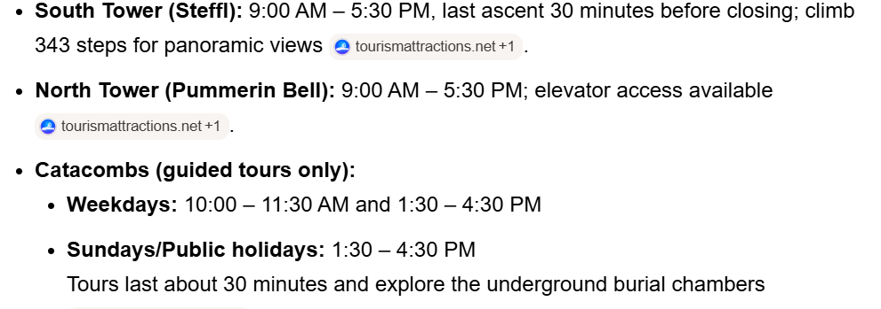

Prague:
https://outsidesuburbia.com/itinerary/3-day-prague-itinerary/#:~:text=3%20Days%20in%20Prague:%20Itinerary,to%20%C4%8Cesk%C3%BD%20Krumlov%20from%20Prague

Main Spot (Must do): Charles River, Prague Castle, Astronomical clock
Prague Castle: Circuit B tickets
https://book.praguecastletickets.com/book/8905/select/?_gl=1%2Axz9l13%2A_gcl_au%2AMTcxNzk0MDA3OS4xNzc3MzU1MzUx%2A_ga%2AMTg3MTE1NjIxMi4xNzc3MzU1MzUy%2A_ga_Y45PC9R73C%2AczE3NzczNTUzNTEkbzEkZzEkdDE3NzczNTYwMDIkajUwJGwwJGgw&cookieBanner=false&currencyCode=EUR&date=2026-08-13&time=09%3A00%3A00&tourId=93323&variantId=96797

– Cheaper but not timed, and not cancellable

https://www.tripadvisor.com/AttractionProductReview-g274707-d11458534-or80-Skip_the_Line_Prague_Castle_Ticket_and_Introductory_Overview-Prague_Bohemia.html
– double price and timed + cancellable

Day |  | What?
08/06/2026 | Thursday | Leave from SFO airport
8/7/2026 | Friday | Reach Vienna at 7:20 PM, reach airbnb, night stay at Vienna
8/8/2026 | Saturday | Historic center of Vienna; St. Stephen’s Cathedral  Hofburg Palace
8/9/2026 | Sunday
8/10/2026 | Monday
8/11/2026 | Tuesday | Vienna to Prague

